**InControl – User Manual**

|  |  |  |
| --- | --- | --- |
| Versie | Reden | Uitvoerder |
| 1.0 | First issue | KHE |
| 1.1 | Draft | SHx |

|  |
| --- |
| Content Table |

1 Introduction 3

2 Configuration setup 4

2.1 General settings 4

2.1.1 License 4

2.1.2 Default acknowledge time 4

2.1.3 Default time-out time 4

2.2 Reasons 5

2.3 Module 6

2.3.1 OPC License 6

2.3.2 Module list 6

2.4 Email 7

2.5 Roles 8

2.6 Users 9

2.7 Groups 10

2.8 Workflow 11

3 Using InControl 12

3.1 Managing bypasses 12

3.1.1 Requesting a new bypass 13

3.1.2 Requesting a group 14

3.1.3 Acknowledging an unrequested bypass 14

3.1.4 Approving bypasses 15

3.1.5 Status overview 16

3.2 Historian 18

3.3 Analyze 19

# Introduction

This document describes the necessary steps to successfully complete an InControl configuration setup. This document can be used together with the customer to go over the basic configuration settings and features to fully configure and use InControl.

This document describes how to successfully set up and use InControl. This document can be used together with the customer to go over the basic configuration settings and features to fully configure and use InControl.

# Configuration setup

## Settings - General

### License

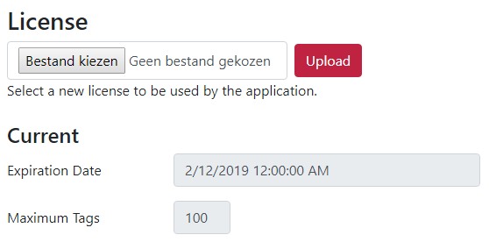

Here you can find/upload your license and the details regarding it.

**IMPORTANT NOTE:** When the amount of tags configured to be monitored is higher than the maximum amount of tags of your license, InControl will no longer read data!

An error message will be displayed saying that you have exceeded the maximum amount of tags.

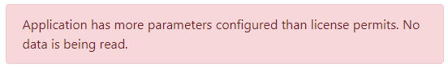

### Default acknowledge time

This setting defines the amount of time a bypass will be acknowledged for by default.

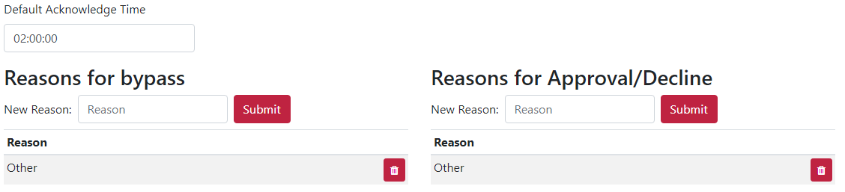

### Default time-out time

If a request has not been approved/declined during the time specified in this setting, then a reminder for approval will be sent via email.

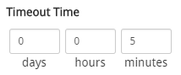

### Reasons

For requesting or approving/declining a bypass. Here you can configure your reasons the users can select.



By default, “Other” is configured. This reason will give an addition field were the user can enter some text to specify the reason. For other used reasons please add them to the list. Some suggestions:

* Maintenance
* Shutdown
* Startup
* I/O problems
* Wrong bypass

By using these default reasons, analyzing will be easier and they will help you optimize your process.

## Settings - Module

Here you can configure which bypasses you want to be monitored.

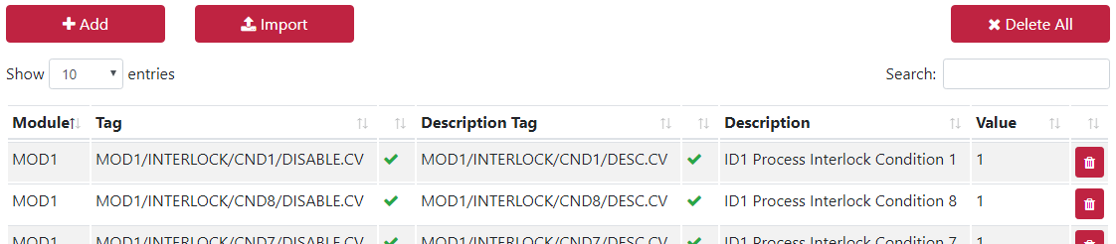

### OPC License

Configure your maximum amount of OPC tags you want InControl to use. This can be useful if you wish to limit the license cost and/or load on your DCS system. Take in consideration that a low limit might cause InControl to update with a high latency. Recommended practice is to take the number of used module tags.

### Module list

Load in your module list through a .csv file or add one manually.

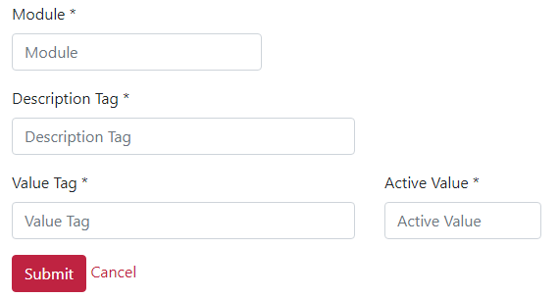

The .csv (comma separated) file has the following format and can be easily generated by a spreadsheet application.

|  |  |
| --- | --- |
| **Module** | Nametag of the module to be monitored |
| **Description Tag** | The parameter that references the description of the bypass.  (Usually the information presented to the operator) |
| **Value Tag** | The parameter that references the actual value of the bypass.  (Usually this is a boolean presented to the operator) |
| **Active value** | Configure this parameter so it matches the value of “**Value Tag**” when the bypass is active. |

## Settings – E-mail

For creating and sending emails you can configure the default SMTP server settings:

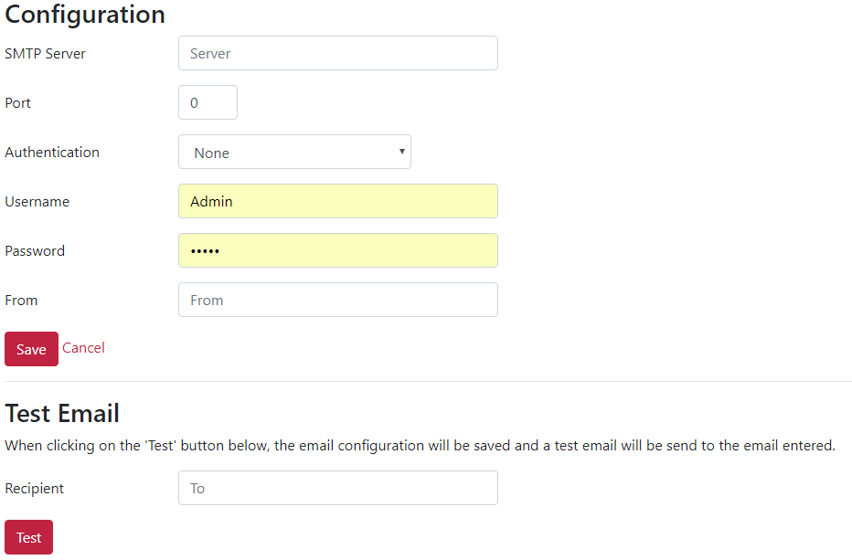

If you don’t use the email functionality you will not be able to send email reminders, notifications for approval and user information when creating account.

There is also an additional feature to send a test email.

## Settings - Roles

InControl by default supports 5 roles. You can use and configure these roles as you require. All the roles can be configured with specific rights based on your site needs. A default configuration has been selected. Please go over these settings to make sure it meets your demands and requirements.

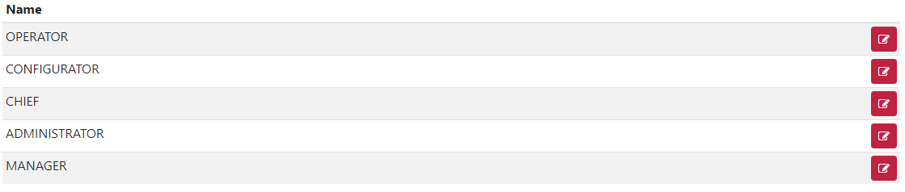

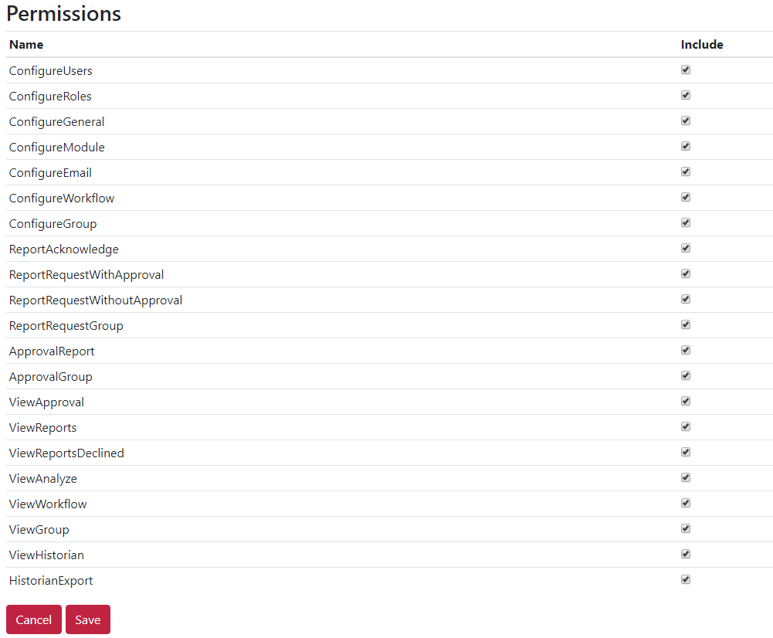

**Operator**: Usually used only for visualization and requesting bypasses

**Chief**: Usually used for low level approval, analytics and creating groups

**Manager**: Usually used for high level approvals of bypasses and groups

**Configurator**: Somebody with configuration rights without being admin (site specific)

**Administrator**: Full rights control

## Settings - Users

Add as many users as you require and assign their roles.

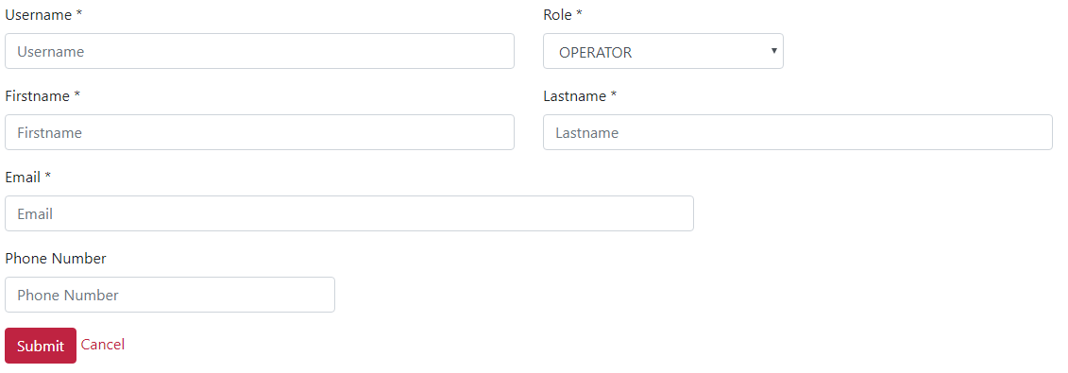

By default, after creating a user an email will be send to the user containing their account login information. When email is not configured the password will be “*default*”. After logging in with your account the user can change this password by clicking on their account name.

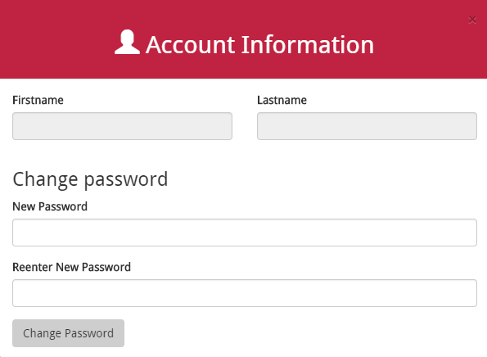

## Groups

Make multiple groups to request bypasses that can be grouped by one request.

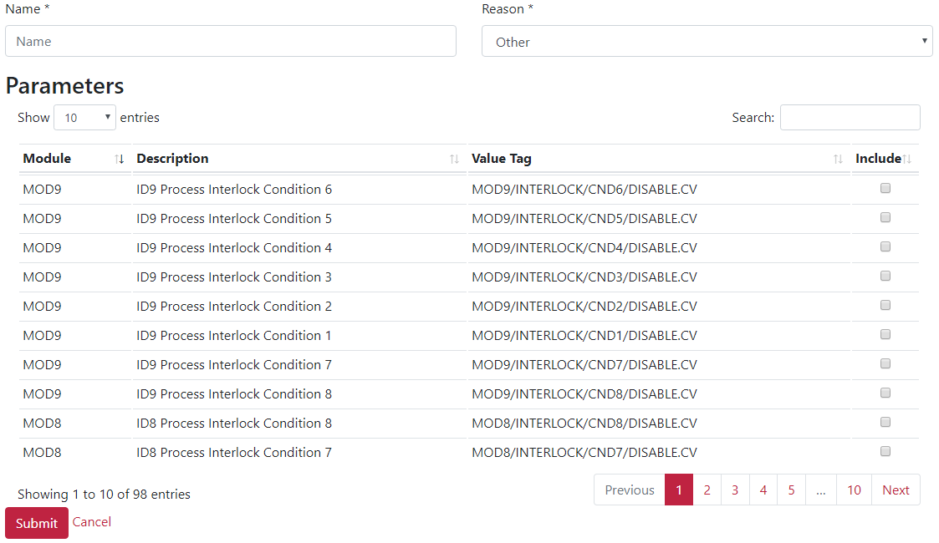

Manage and view the status of your groups.

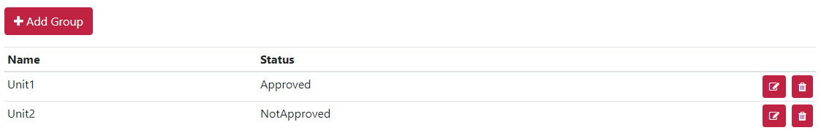

When you add a new group, it needs to get approved before you can use it. A notification will appear on the approval tab. There the group can be approved or declined.

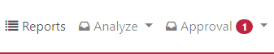

## Workflow

Manage and create your workflows that define how the request will be processed.

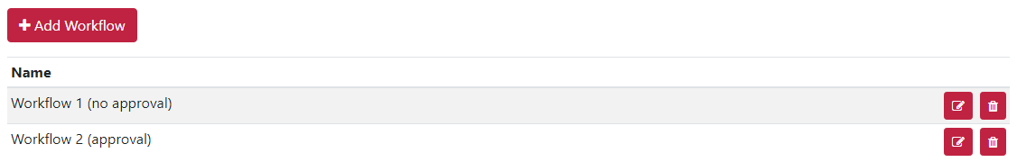

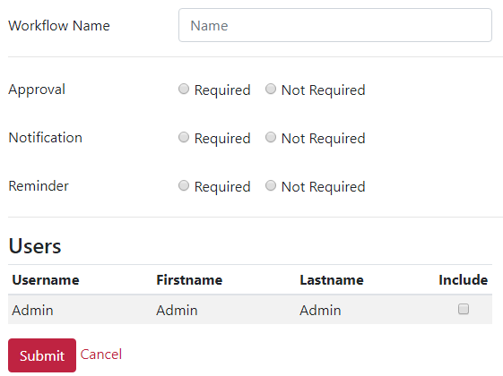

Here you can define whether the request needs approval, a notification e-mail and a reminder e-mail. You can also select to which user the e-mails should be sent to.

# Using InControl

## Managing bypasses

Now that you have successfully set up InControl, you can start monitoring the desired bypasses. On the  page, you have a clean overview of all your bypasses:

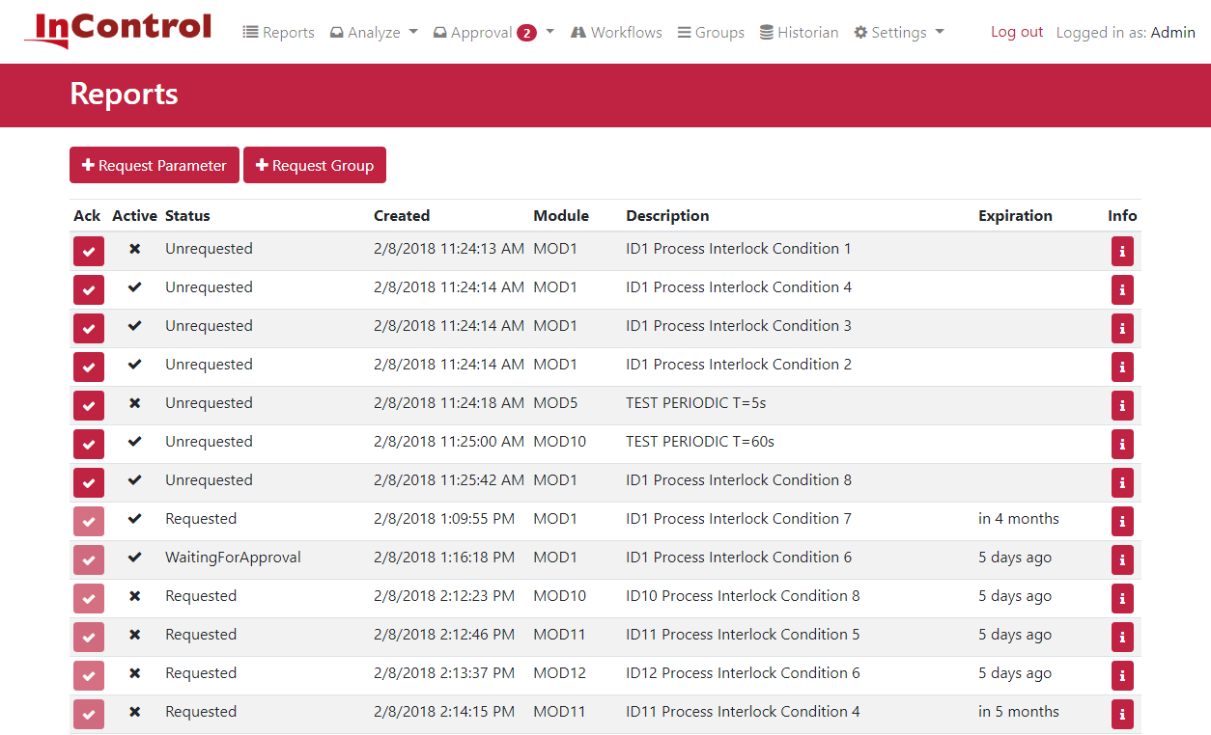 On this page you have access to the following info:

* The status of the bypass, whether is active or not.
* The status of the request, as explained in the flowchart (see 3.1.4 Status overview)
* The timestamp when the request was made or when an unrequested bypass became active.
* The name of the module that is being bypassed.
* The description of what exactly is being bypassed.
* The date when the requests will expire.

When you press the info button , you get access to additional info such as:

* The parameter that is being monitored.
* Which user requested the bypass
* For what reason they requested a bypass

### Requesting a new bypass

By clicking on , you can request a single new bypass. This opens the following page:

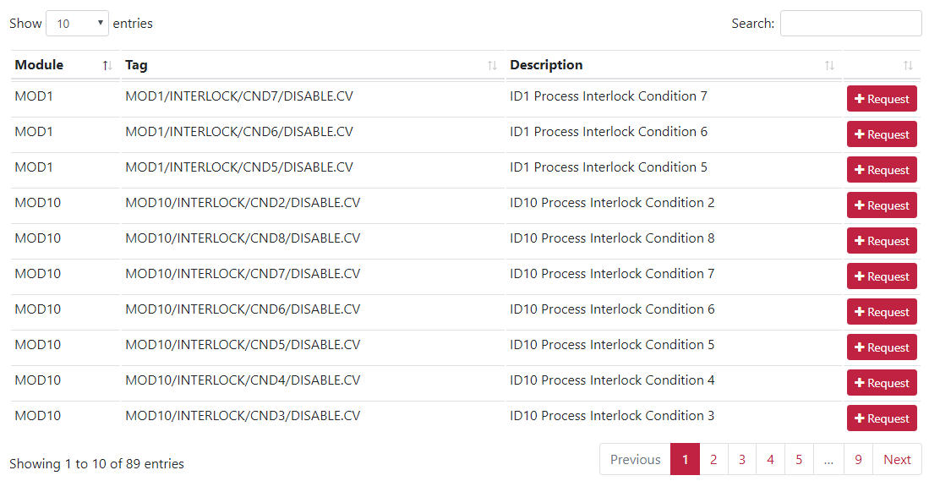

Here you can search and select which parameter you need. Once you have it, press

Then you define which workflow it should use, for what reason you want to activate the bypass and for how long it should be active.

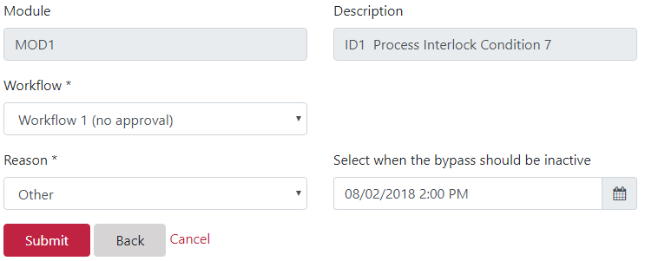

### Requesting a group

By clicking on , you can request a single new bypass. This opens the following page. Here you select the group you wish to request, the workflow and the time until the request lasts:

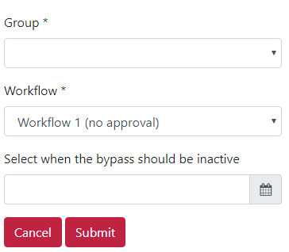

### Acknowledging an unrequested bypass

Here we have an active bypass that wasn’t requested:



If you want to acknowledge the bypass, you can do so by clicking the .

Then you do the same as with requesting a bypass: you define which workflow it should use, for what reason you want to activate the bypass and for how long it should be active.

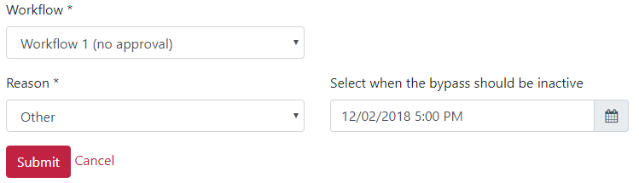

### Approving bypasses

When a user has requested a bypass using a workflow that requires approval, then another user with the right to approve or declines requests must decide what will happen.

When there are requests that need to be checked for approval, a notification will appear in the next to the approval button:

   
The number indicates the number of items that await approval. When a new group is made, it also appears here for approval.



By clicking approve/decline the following menu opens:

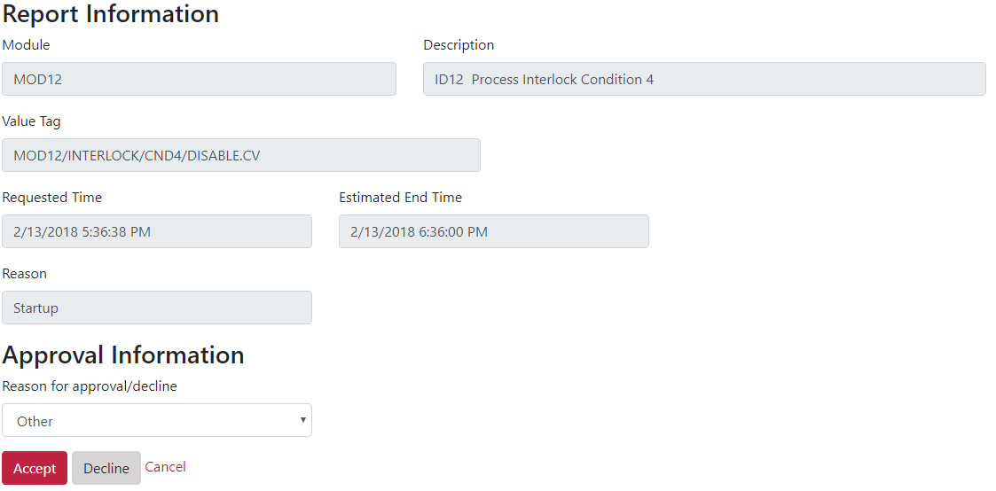

Here the user can approve or decline the requests and select a reason why.

### Status overview

The following flowchart explains how InControl processes your bypasses:

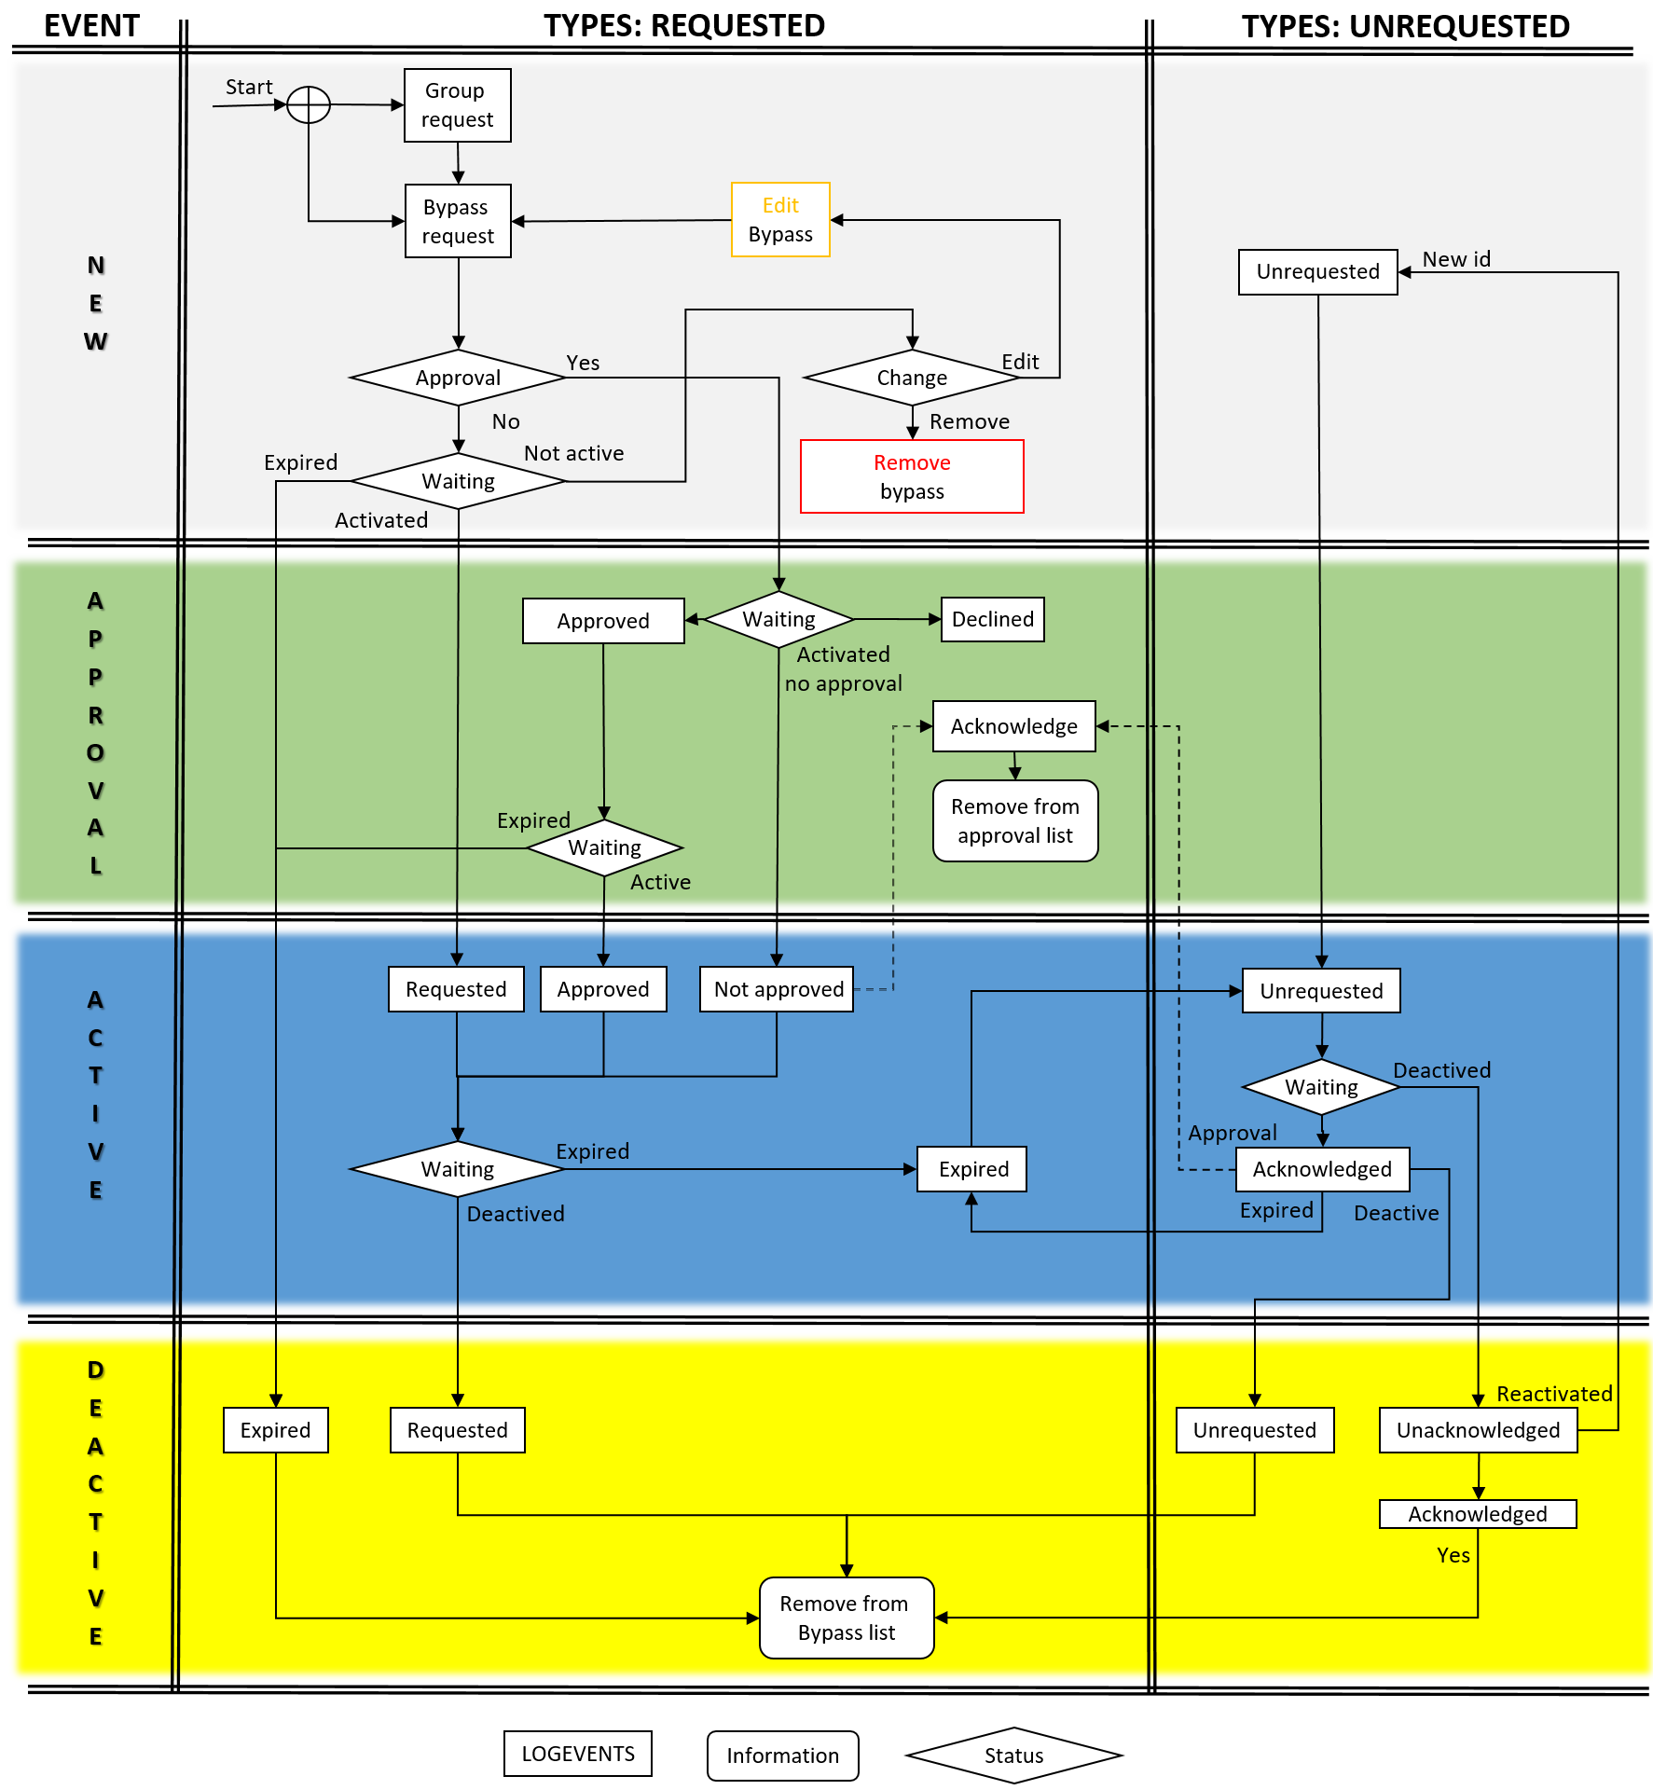

All the bypasses are divided in 2 groups:

* Requested: Bypasses that have been requested using either  
   or 
* Unrequested: Bypasses that have been activated on your control system without a request in InControl

Furthermore, the bypasses also have 4 different states:

* **New**: requesting a new bypass/group of bypasses. Requested bypasses waiting to become active.
* **Approval**: requested bypasses waiting to be approved/declined. Also waiting to become active.
* **Active**: when a requested/unrequested/approved bypass is active.
* **Deactive**: when a requested/unrequested/approved bypass becomes inactive.

The historian (see 3.2 Historian) is build up from all the log events (the square fields on the flow chart).

*To be added(?): Interactive image of the flowchart that shows what each event looks like in the user interface*

## Historian

On the historian page  you can view all events regarding the bypasses and requests, but also when changes are made to the configuration of your InControl setup. Below is a table with all the possible items that can appear in the historian.

|  |  |  |  |  |  |  |  |  |  |  |  |  |  |  |
| --- | --- | --- | --- | --- | --- | --- | --- | --- | --- | --- | --- | --- | --- | --- |
| **Timestamp** | **id** | **Event** | **Type** | **Workflow** | **User** | **Name** | **Condition** | **Description** | **Log Type** | **Reason** | **EndTime** | **Extra** | **Intation info** | |
| 27/06/2017 11:00 |  | NEW | BYPASS | <workflowname> | <username> | <modulename> | <condition> | <conditiondescription> | System | <reason>: <+desc> | <endtime> |  | | User requests a new bypass |
| 27/06/2017 11:00 |  | NEW | GROUP | <workflowname> | <username> | <groupname> |  |  | System | <reason>: <+desc> | <endtime> |  | | User requests a new group |
| 27/06/2017 11:00 |  | NEW | GROUP |  | <username> |  |  |  | Audit | <reason>: <+desc> |  |  | | User creates a new group |
| 27/06/2017 11:00 |  | NEW | USER |  | <username> |  |  |  | Audit |  |  | <newusername>,  <firstname>,<lastname>,  <email>,<role> | | A new user is created |
| 27/06/2017 11:05 |  | APPROVAL | APPROVED | <workflowname> | <username> | <modulename> | <condition> | <conditiondescription> | System | <reason>: <+desc> | <endtime> | <motivation> | | User approves a requested bypass |
| 27/06/2017 11:05 |  | APPROVAL | DECLINED | <workflowname> | <username> | <modulename> | <condition> | <conditiondescription> | System | <reason>: <+desc> | <endtime> | <motivation> | | User declines a requested bypass |
| 27/06/2017 11:10 |  | EDIT | GROUP |  | <username> | <groupname> |  |  | Audit | <reason>: <+desc> |  |  | | User edits an existing group |
| 27/06/2017 11:10 |  | EDIT | USER |  | <username> |  |  |  | Audit |  |  | <from>,<to> | | User edits an existing user |
| 27/06/2017 11:10 |  | EDIT | BYPASS | <workflowname> | <username> | <modulename> | <condition> | <conditiondescription> | System | <reason>: <+desc> | <endtime> |  | | User edits an existing workflow |
| 27/06/2017 11:20 |  | REMOVE | BYPASS | <workflowname> | <username> | <modulename> | <condition> | <conditiondescription> | System | <reason>: <+desc> | <endtime> |  | | Removing a requested bypass that hasn’t been active yet |
| 27/06/2017 11:20 |  | REMOVE | USER |  | <username> |  |  |  | Audit |  |  | <newusername>,  <firstname>,<lastname>  ,<email>,<role> | | Removing an user |
| 27/06/2017 11:20 |  | REMOVE | GROUP |  | <username> |  |  |  | Audit | <reason>: <+desc> |  |  | | Removing a group |
| 27/06/2017 11:30 |  | ACTIVE | UNREQUESTED | Undefined | <system> | <modulename> | <condition> | <conditiondescription> | System |  |  |  | | An unrequested bypass became active |
| 27/06/2017 11:30 |  | ACTIVE | EXPIRED | <workflowname> | <system> | <modulename> | <condition> | <conditiondescription> | System | <reason>: <+desc> | <endtime> |  | | An acknowledged/requested bypass expired |
| 27/06/2017 11:30 |  | ACTIVE | REQUESTED | <workflowname> | <system> | <modulename> | <condition> | <conditiondescription> | System | <reason>: <+desc> | <endtime> |  | | A requested bypass became active |
| 27/06/2017 11:30 |  | ACTIVE | UNREQUESTED ACKNOWLEDGED |  |  |  |  |  |  |  |  |  | | ??? |
| 27/06/2017 11:40 |  | DEACTIVE | UNREQUESTED |  | <system> | <modulename> | <condition> | <conditiondescription> | System |  |  |  | | An unrequested bypass became inactive |
| 27/06/2017 11:30 |  | DEACTIVE | EXPIRED | <workflowname> | <system> | <modulename> | <condition> | <conditiondescription> | System | <reason>: <+desc> | <endtime> |  | | A deactivated, requested bypass expired |
|  |  | DEACTIVE | ACKNOWLEDGED | <workflowname> | <system> | <modulename> | <condition> | <conditiondescription> | System | <reason>: <+desc> | <endtime> |  | | A deactivated, unrequested bypass has been acknowledged |
| 27/06/2017 11:40 |  | DEACTIVE | REQUESTED | Undefined | <system> | <modulename> | <condition> | <conditiondescription> | System | <reason>: <+desc> | <endtime> |  | | A requested bypass expired |

## Analyze

These pages provide you analytic insights over the bypasses on your system:

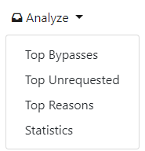

* Top Bypasses: the top 5 most activated bypasses.
* Top Unrequested: the top 5 most activated bypasses without a request.
* Top Reasons: the top 5 most used reasons to request a bypass
* Statistics: *TBD*

